Problem Statement:
Organizations face difficulties in managing shared resources like classrooms, labs, auditoriums, and meeting rooms due to manual processes, leading to double bookings, poor utilization, and lack of transparency.
Project Objectives:
- Digitize resource booking and management
- Ensure transparency and avoid conflicts
- Improve utilization and maintenance tracking
Target Users:
Students – Can view available resources and submit booking requests for academic or event purposes.
Employees – Can request, view, and manage bookings for organizational meetings or activities.
Faculty – Can book resources for classes, exams, seminars, and approve requests if authorized.
Administrators – Have full control over users, resources, approvals, maintenance, and reports.
Functional Requirements:
- User authentication and role management
- Resource listing and categorization
- Booking request and approval workflow
- Maintenance scheduling
- Reports and dashboard
Non-Functional Requirements:
- Security and data protection
- Performance and scalability
- Usability and responsiveness
- Reliability and availability
User Roles & Permissions:
- Admin: Manage users, resources, approvals, reports
- Approver: Approve or reject bookings
- User: Request and view bookings

Use Case Identification:
- Login / Logout
- Create booking request
- Approve or reject booking
- View reports
- Manage resources

ER Diagram:
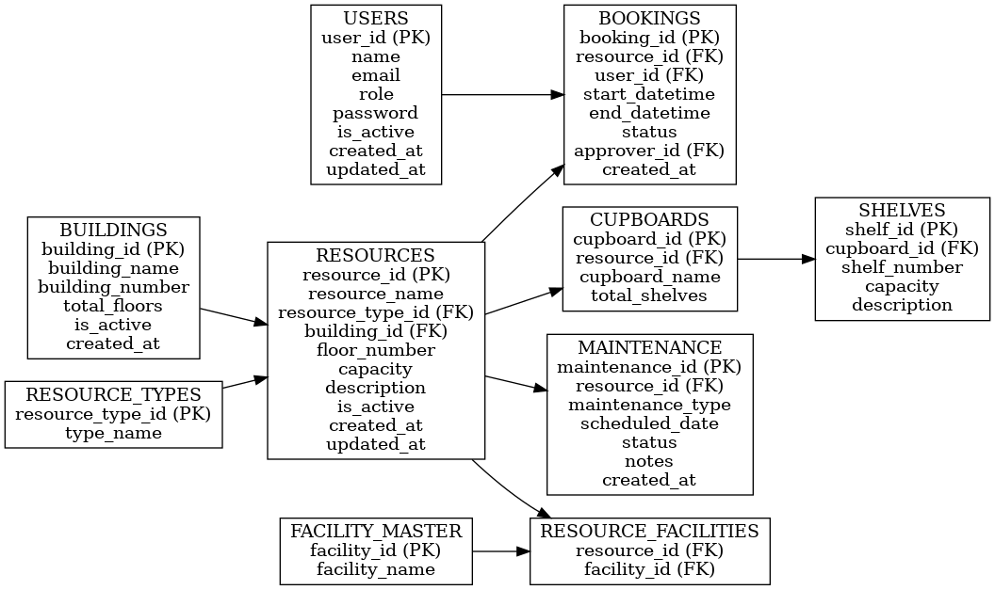

Data Flow Mapping:
- User → Booking Request → Approval → Confirmation
- Booking Approval → Maintenance Notification
- Admin → Reports & Analytics

